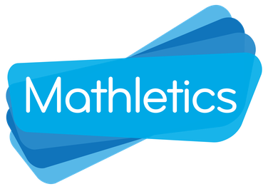

At Riverside we have access to Mathletics to help us work on our maths.

To access the program there is an icon on the home screen of the school laptop or you can type ‘Mathletics’ into Google.

There is no due date for activities to be completed on Mathletics, but they will be monitored and the activities will be updated each term. There are also games on Mathletics for your child to enjoy and develop their mathematical skills.

Thank you for your support,

Lucy

