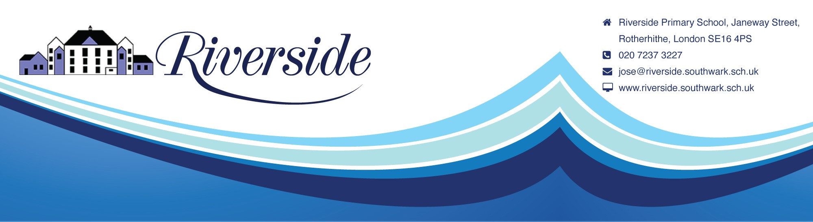
September 2022
Dear Parents
When You’re Smiling!
Oh what happy faces there were this morning – I am taking this as you being happy to see us and not that you were happy to wave your dear ones goodbye! I am sure you have looked forward to getting coffee mornings uniforms organised again.

I hope you have had a great holiday – can’t say the rain spoilt it – and you are all relaxed but raring to go. Once again, thank you for all the kind words and gifts received at the end of term; it is appreciated and great to hear.

So, just to start the term with the usual housekeeping stuff, please remember to collect your uniform from Gill as soon as you can and the school colour is navy blue. A quick reminder that jewellery and make up are not schoolwear (and this includes nail varnish!) so please work with us on that.
The teachers will be telling you the days the children have PE but remember that they should be wearing uniform and changing for PE, not wearing their kit all day – there will be a letter regarding this soon.
If you require Breakfast Club or Play Centre places you should have emailed me by now – please do so if you want a place. Details of fees will be going out this week via email. If you do not have access to email, please let me know.
An LA Healthy Schools policy has come into force this year and more details will follow, particularly about packed lunches and drinks. Please ensure your child has their water bottle each day and it is labelled clearly.
To finish, I am aware that communication is something we have to improve. Since lockdown we have not had the same level of contact with parents. So, as a start, what we aim to do is put all letters sent out on the “Breaking News” bit of the website so that if you have missed the paper copy you can access the letters and if you do not have access to the internet, the paper one is there for you. Hopefully, this one should be there already! But as always you can email me at any time or see one of us at the gate.
Happy Autumn Term and Welcome Back!



