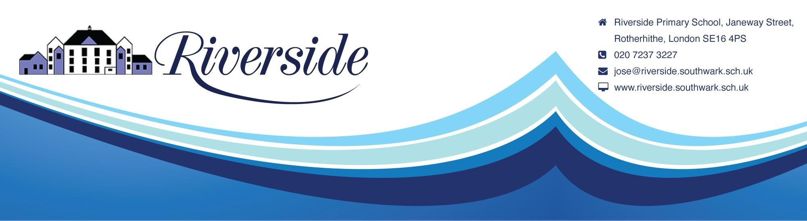
November 2022
Dear Parents

INFANT NATIVITY

Early Years and Key Stage 1 (Tugs, Ferries, Lifeboats, Dinghies, Sailboats and Speedboats)
The Infant Nativity will take place on Tuesday 6th December 2022 at the following times:

10.00AM – Tugs, Ferries and Dinghies
2.00PM – Lifeboats, Sailboats and Speedboats

Parents will need to book a place to be able to attend. Those who have not booked will not be allowed onto the school premises. Please enter by the gate in Farncombe Street where you will be met by a member of staff.
You may book a maximum of 2 audience places only for one performance by emailing bookings@riverside.southwark.sch.uk If you have more than one child in the Key Stage, please book for the eldest child’s performance only. Please state the name/s of the person/s who will attend. You will receive a confirmation email once we receive your request.

Please note that you must book by 3.30pm on Friday 2nd December.

