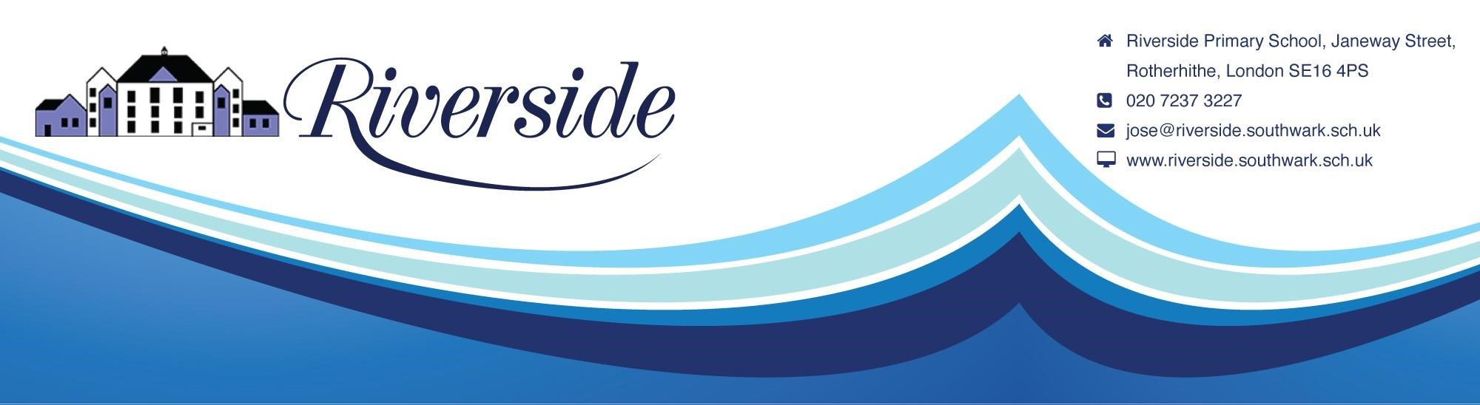
November 2022
Dear Parents

JUNIOR CAROL CONCERT

Key Stage 2 (Longboats, Gondolas, Narrowboats, Paddleboats, Liners, Skipjacks and Clippers)
The Junior Carol Concert will take place on Wednesday 7th December 2022 at 2.00PM.

We have decided to take the concert into the playground for a “carol singing” type of concert and hope the weather will be kind to us.

You will not need to book. Enter by the gate in Janeway Street.

There will be restrictions as to where you will be able to stand. There will be no seating. If we have to cancel/reschedule due to the weather, please look for the notices at the gates and on the website.

