FOUNDATION STAGE UNITS OF WORK
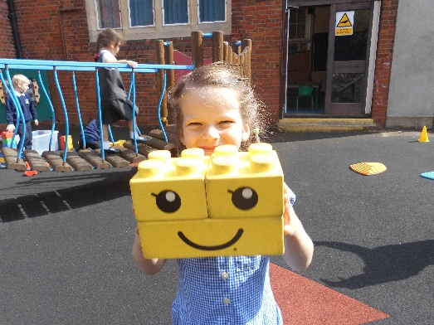

YEAR A | YEAR B
CELEBRATIONS AROUND THE WORLD | ALL ABOUT ME
HOMES | GROWING IN THE GARDEN
MINIBEASTS | JOURNEYS
OUR LOCAL AREA | LIGHT AND DARK
OUR SCHOOL COMMUNITY | PEOPLE WHO HELP US
WATER, WIND, WEATHER | STORIES FROM AROUND THE WORLD
