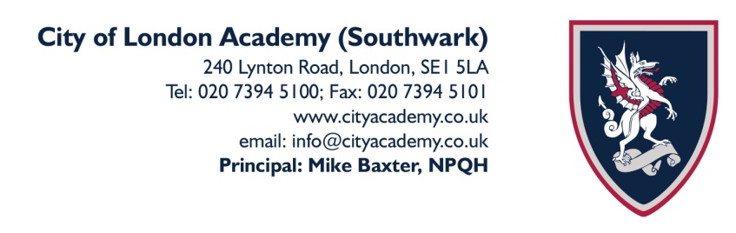
14th September 2020

Dear Parents and Carers

We would like to take this opportunity to invite you to our forthcoming Virtual (Online) Open Events. We are a high achieving and heavily oversubscribed academy. The majority of our students leave us with a wealth of opportunities for their next steps, be that employment, apprenticeships or entry into leading universities including Oxbridge.

The City of London Corporation sponsors the City of London of Academy (Southwark), enabling our students to also access unique, exciting career opportunities.
City of London Academy (Southwark) Open Events 2020:
Please see below the available dates for our Virtual (Online) Open events. Please pick your preferred event and follow the link to book via Eventbrite on the City of London Academy (Southwark) website or click on the link below.
https://www.cityacademy.co.uk/year-6-virtual-open-events-2020/287.html
Dates for the Lower School Virtual Open Events
Thursday 17th September 2020 Open Morning: 9:00am -10:00am
Tuesday 22nd September 2020 Open Evening Session 1: 4:00pm – 5:00pm
Tuesday 22nd September 2020 Open Evening Session 2: 6:00pm – 7:00pm
Thursday 24th September 2020 Open Morning: 9:00am – 10:00am
Tuesday 29th September 2020 Open Morning: 9:00am – 10:00am
Once you have booked via the Eventbrite link, we will email you with a meeting link to join the open event on the specified date/time that you have chosen. You will receive an email with the meeting link 24hrs before the relevant open event. Please ensure that you book via Eventbrite with a working email address to receive the open event meeting link. We look forward to welcoming you to these open events.
Yours sincerely

Myra Swartz Ashley Reddin
Vice Principal Head of Transition

