REGANS SOCCER SCHOOL HOMEWORK
KS2
Please see attached images and find out three rules for the sport, two pieces of equipment needed to play the sport and name one major tournament where teams compete in the sport.
1.)
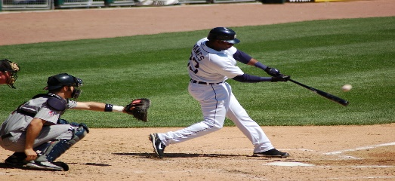 BASEBALL
This Photo by Unknown Author is licensed under CC BY-SA

2.)
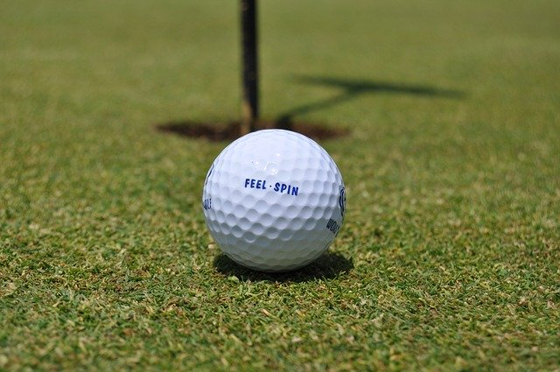 GOLF

3.)
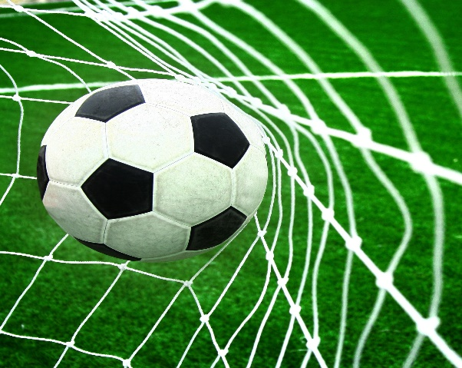FOOTBALL
This Photo by Unknown Author is licensed under CC BY

4.)
BASKETBETBALL

5.)
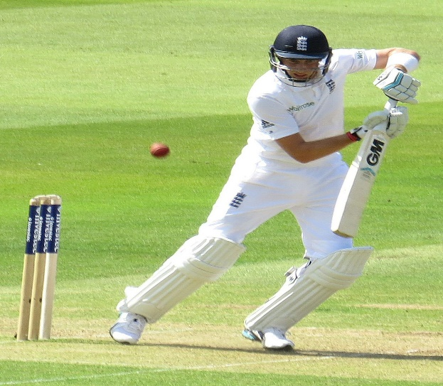CRICKET
This Photo by Unknown Author is licensed under CC BY-SA

