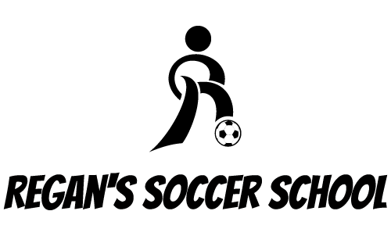
REGANS SOCCER SCHOOL HOMEWORK

Please see below Sporting celebrities I have chosen and find out the information for the questions I have provided about them. Feel free to use google to find the answers that you need.

MICHAEL JORDAN
. What is the name of MJ first ever basketball team he played for?
. Where was he born?
. what is the name of his new documentary on Netflix called?

SIR ALEX FERUSON
. What country is he from?
. How long did it take him to win his first premier league title?
. Which year did he retire?

MO FARAH
. Which sport does Mo compete in?
. What height is he?
. Where was he born?

GENNADY GOLOVKIN
. Which sport does he take part in?
. Who was his last fight against?
. Who is he sponsored by?

JESSICA ENNIS
. Which racing event does Jessica race in? 100Metre, 500Metre or 1500Metre?
. Has she taken part in the Olympics?
. What year did she retire?

