REGANS SOCCER SCHOOL HOMEWORK
KS1
Please see attached images and figure out the name of the person or object. Use the clues I have given you by typing them in google to find out the answer. Good Luck.
1.)
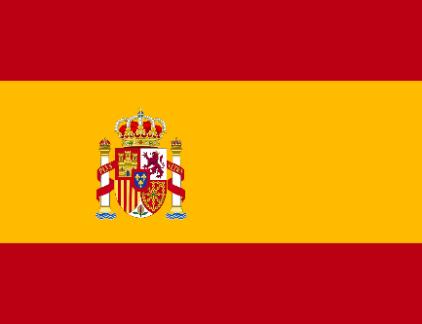 Clue – Red & Yellow flag, Barcelona and Madrid

2.)
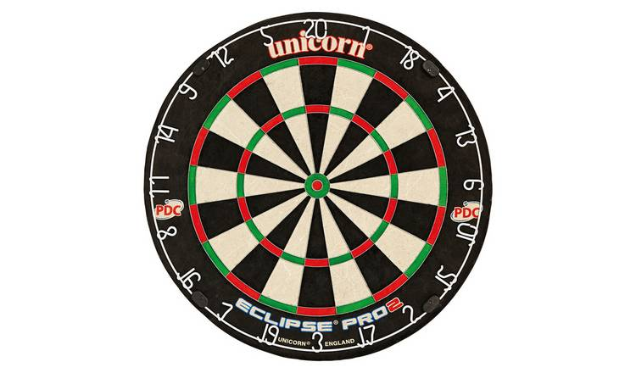 Clues – bullseye, treble 20 & circular target

3.) 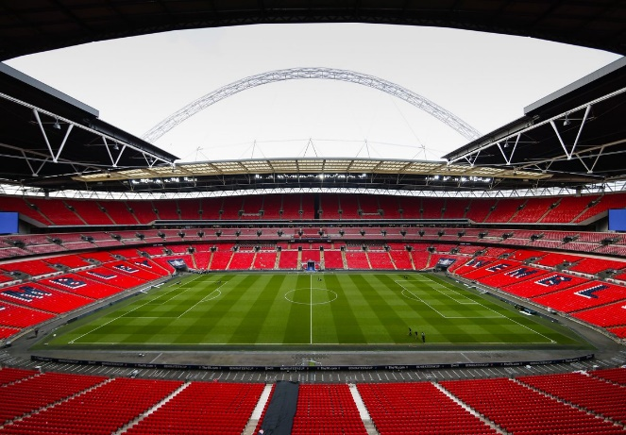Clue – Englands football home ground.

4.)
Clue – Basketball player for lakers, number23

5.)
Clue – Football team based in South London, their home ground is called The Den, they play in the Championship League

