REGANS SOCCER SCHOOL HOMEWORK
KS1
Please see attached images of each sport and find out one rule for the sport and name two pieces of equipment needed to play the sport.
1.)
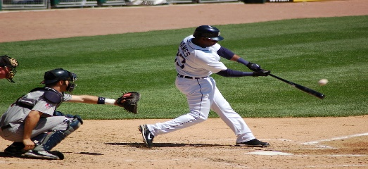 BASEBALL
This Photo by Unknown Author is licensed under CC BY-SA

2.)
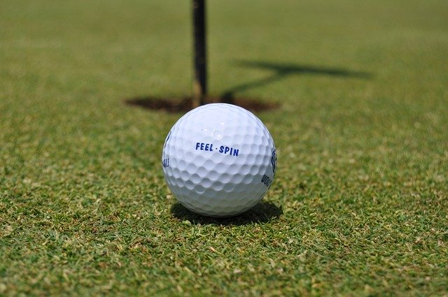 GOLF

3.)
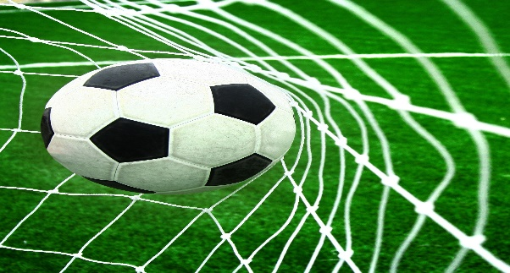FOOTBALL
This Photo by Unknown Author is licensed under CC BY

4.)
BASKETBETBALL

5.)
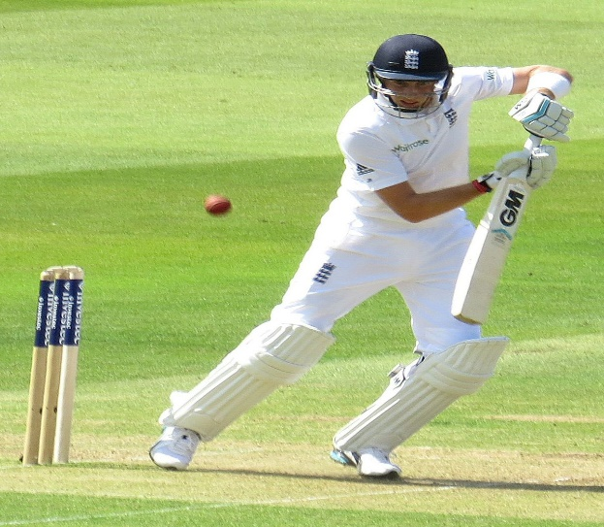CRICKET
This Photo by Unknown Author is licensed under CC BY-SA

